We recently came across a paper that explained the equality between the parameters of signal detection theory (SDT) and the parameters of logistic regression in which the state (“absent”/“present”) is used to predict the response (“yes”/“no”, but also applicable in scale-rating designs) (DeCarlo, 1998; [DOI: 10.1037/1082-989X.3.2.186](http://dx.doi.org/10.1037/1082-989X.3.2.186)).

Here is a short simulation-proof for this equality.

**Setup**

For this simulations we will need the following packages:

# For plotting

library(ggplot2)

# For extracting SDT parameters

library(neuropsychology)

We will also need to make sure, for the logistic regression analysis, that our factors’ dummy coding is set to effects-coding – otherwise the intercept’s meaning will not correspond to the criterion (aka the *overall* response bias):

options(contrasts = c('contr.sum', 'contr.poly'))

**The Simulations**

n <- 100L

B <- 100L

We’ll run 100 simulations with 100 trials each.

**Simulation Code**

set.seed(1)

SDT_params <- function(state,resp) {

tab <- table(state,resp)

sdt_res <- neuropsychology::dprime(

n_hit = tab[2,2],

n_miss = tab[2,1],

n_fa = tab[1,2],

n_cr = tab[1,1]

)

c(sdt_res$dprime , sdt_res$c)

}

logistic_reg_params <- function(state,resp){

fit <- glm(resp ~ state, family = binomial())

coef(fit)

}

# initialize

res <- data.frame(d_ = numeric(B),

c_ = numeric(B),

int = numeric(B),

slope = numeric(B))

# Loop

for (b in seq_len(B)) {

true_sensitivity <- rexp(1,10) # random

true_criterion <- runif(1,-1,1) # random

# true state vector

state_i <- rep(c(F,T), each = n/2)

# response vector

Xn <- rnorm(n/2) # noise dist

Xs <- rnorm(n/2, mean = true_sensitivity) # signal + noise dist

X <- c(Xn,Xs)

resp_i <- X > true_criterion

# SDT params

res[b,1:2] <- SDT_params(state_i,resp_i)

# logistic regression params

res[b,3:4] <- logistic_reg_params(state_i,resp_i)

}

**Results**

SDT parameters are on a standardized normal scale, meaning they are scaled to \(\sigma=1\). However, the logistic distribution’s scale is \(\sigma=\pi/\sqrt3\). Thus, to convert the logistic regression’s parameters to the SDT’s we need to scale both the *intercept* and the *slope* by \(\sqrt3/\pi\) to have them on the same scale as \(c\) and \(d'\). Additionally,

1. The slope must be also scaled by \(-2\) due to R’s default effects coding.
2. The intercept must also be scaled by \(-1\) – see paper for the full rationale.

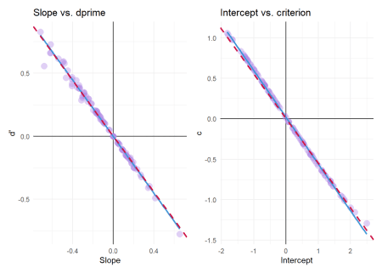

The red-dashed line represents the expected regression line predicting the SDT parameters from their logistic counterparts:

* \(d' = -2\times\frac{\sqrt{3}}{\pi}\times Slope\)
* \(c = -\frac{\sqrt{3}}{\pi}\times Intercept\)

(The blue line is the empirical regression line.)

**Conclusions**

I haven’t tested here how this equality can be extended to multi-level designs with generalized linear mixed models (GLMM), but I see no reason this wouldn’t be possible… One could model random effects per subject, and the moderating effect of some \(X\) on sensitivity could in theory be modeled by including an interaction between \(X\) and *state*; similarly, the moderating effect of \(X\) on the criterion can be modeled by including a main effect for \(X\) (moderation the intercept).